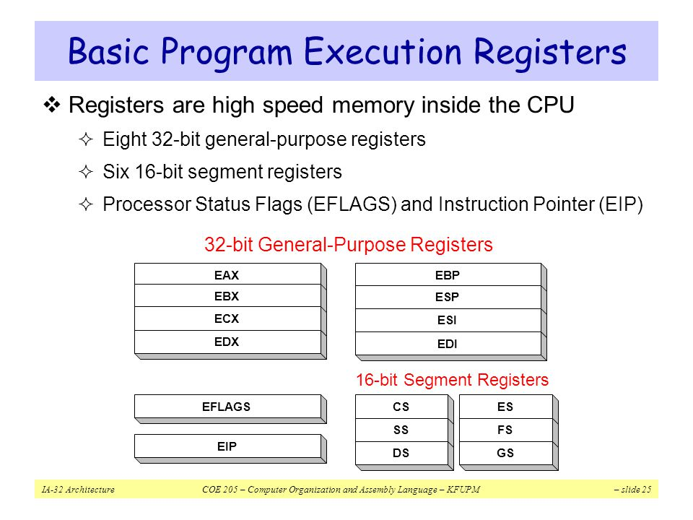
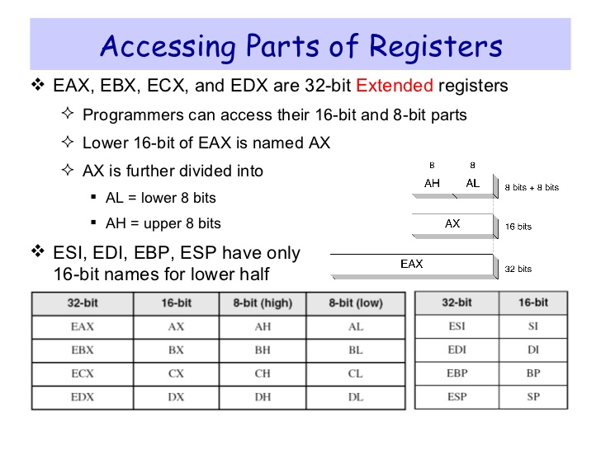

Data definition directives

DB – byte data type (BYTE)
DW – word data type (WORD)
DD – doubleword data type (pointer - DWORD)
DQ – 8 bytes data type (QWORD – 64 bits)
DT – 10 bytes data type (TWORD – used to store BCD constants or real constants for extended precision)

For example, the following sequence defines and initializes 5 memory variables:

; this is the data segment
segment data use32 class=data
a DB 7 ; 1 byte
b DW 101b ; 2 bytes (1 word)
c DD 2bfh ; 4 bytes (1 doubleword)
d DQ 307o ; 8 bytes (1 quadword)
e DT 1024 ; 10 bytes

Source line format

In the x86 assembly language the source line format is:

[label[:]] mnemonic [operands] [;comment]

- typically one statement per line
- fields in [ ] are optional
- all identifiers are case sensitive
- the allowed characters for a label are:
  - letters: A – Z, a – z;
  - digits: 0 – 9;
  - special characters: _ $ # @ ~ . ?
  - a label name is valid, if it starts with a letter, _ or ?
- mnemonic identifies the operation to be executed (e.g. add, mov)
- operands specify the data required by the operation
- comments begin with a semicolon (;) and extend to the end of the line

Example:
segment code use32 class=code
start:
jmp here
...
here: mov AL, 7

Other examples:

mov EAX, a ; loads into EAX register the address (offset) of data or code starting at label a
mov EAX, [a] ; loads into EAX register the content from address a (4 bytes)

Type operators

They specify the types of some expressions or operands stored in memory. Their syntax is:

type expression
where the type specifier is one of the following: BYTE, WORD, DWORD, QWORD or TWORD

Example:

; this is the data segment
segment data use32 class=data
b DW 1024 ; 2 bytes (1 word)

; this is the code segment
segment code use32 class=code
start:
mov al, byte [a]

MUL multiplier

a. When two bytes are multiplied
The multiplicand is in the AL register, and the multiplier is a byte in the memory or in another register.
The product is in AX.
High-order 8 bits of the product is stored in AH and the low-order 8 bits are stored in AL.

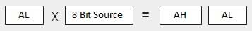

b. When two one-word values are multiplied
The multiplicand should be in the AX register, and the multiplier is a word in memory or another register.

For an instruction like MUL DX, you must store the multiplier in DX and the multiplicand in AX.

The resultant product is a doubleword, which will need two registers. The high-order (leftmost) portion gets stored in DX and the lower-order (rightmost) portion gets stored in AX.

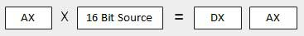

c. When two doubleword values are multiplied
When two doubleword values are multiplied, the multiplicand should be in EAX and the multiplier is a doubleword value stored in memory or in another register.

The product generated is stored in the EDX:EAX registers, i.e., the high order 32 bits gets stored in the EDX register and the low order 32-bits are stored in the EAX register.

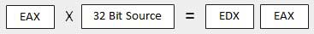

DIV divisor

a. When the divisor is 1 byte
The dividend is assumed to be in the AX register (16 bits).

After division, the quotient goes to the AL register and the remainder goes to the AH register.

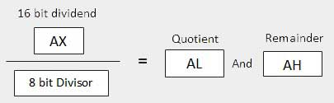

b. When the divisor is 1 word
The dividend is assumed to be 32 bits long and in the DX:AX registers.
The high-order 16 bits are in DX and the low-order 16 bits are in AX.

After division, the 16-bit quotient goes to the AX register and the 16-bit remainder goes to the DX register.

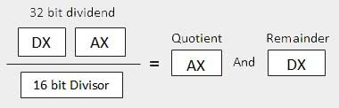

c. When the divisor is doubleword
The dividend is assumed to be 64 bits long and in the EDX:EAX registers.
The high-order 32 bits are in EDX and the low-order 32 bits are in EAX.

After division, the 32-bit quotient goes to the EAX register and the 32-bit remainder goes to the EDX register.
